Coding Test: Solve the Longest Common Substring problem via HTTP POST

Tools Used: IntelliJ IDEA, Swagger Framework To build an automatic webpage, Postman to check if I get appropriate request and response.

Instructions To Run a Code:

1 option Run with IDE
--------------------------------
Install JDK 8 -> https://www.guru99.com/install-java.html
Install Maven -> https://mkyong.com/maven/how-to-install-maven-in-windows/
Download IntelligentIdea Ultimate -> https://www.jetbrains.com/ru-ru/idea/download/#section=windows
Activate trial version
Open my project with Intelligent Idea
Click by View -> Appearance -> Toolbar
You can see the toolbar.
Inside the toolbar you can see build option -> click by green arrow
Wait untill the build is completed
Click by build world and select PriyaApplication from the drop down
Click by green arrow
Wait untill the server is run
Go to chrome or any browser and type http:/localhost:8080/swagger-ui.html
Now you can see the page when yu can run your request
Click by Controller row -> click by /lcs green row -> click by Try it out button
Write your request and click the execute button

You can see the response under the Responses line.
--------------------------------

Run on any computer or server
--------------------------------
Install JDK 8 -> https://www.guru99.com/install-java.html
Make sure that the JDK was installed
This WHOLE_PATH_TO_THE_FOLDER_WITH_PROJECT you need to replace with your path
Run the command with CMD " WHOLE_PATH_TO_THE_FOLDER_WITH_PROJECT priya/target/priya-0.0.1-SNAPSHOT.jar"
Or just copy paste the jar file that I sent to you to any folder and run the the same command
After that go to the browser and open http:/localhost:8080/swagger-ui.html and test it.

Algorithm response:
Input:
{
"setOfStrings": [
{"value": "comcast"},
{"value": "comcastic"},
{"value": "broadcaster"}
]
}
Output:

{
"lsc": {
"value": "cast"
}
}
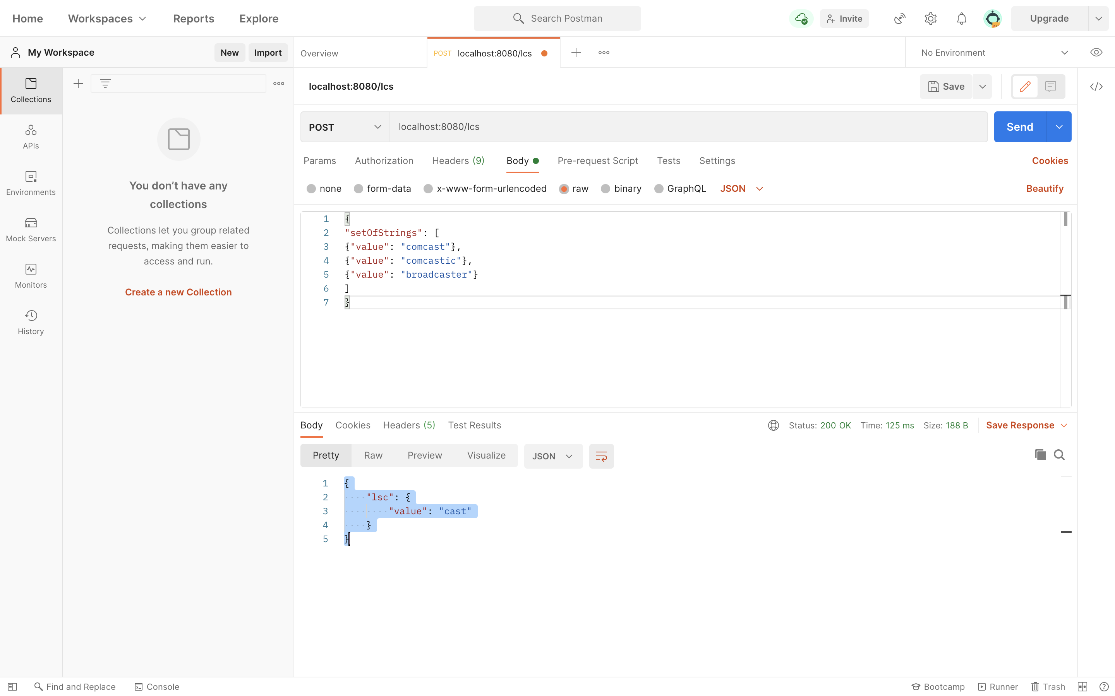

Validation:

- If post Body is empty:

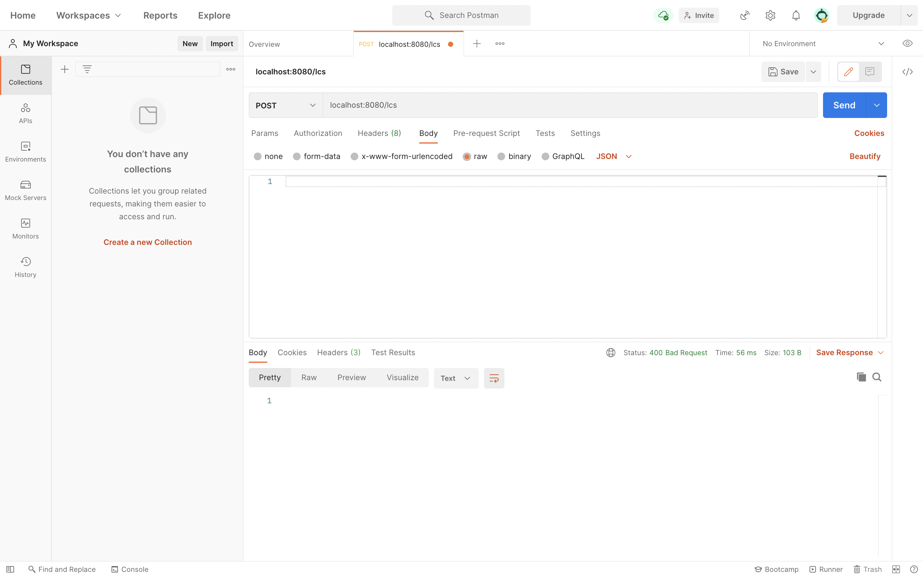

- If SetofString is null/empty

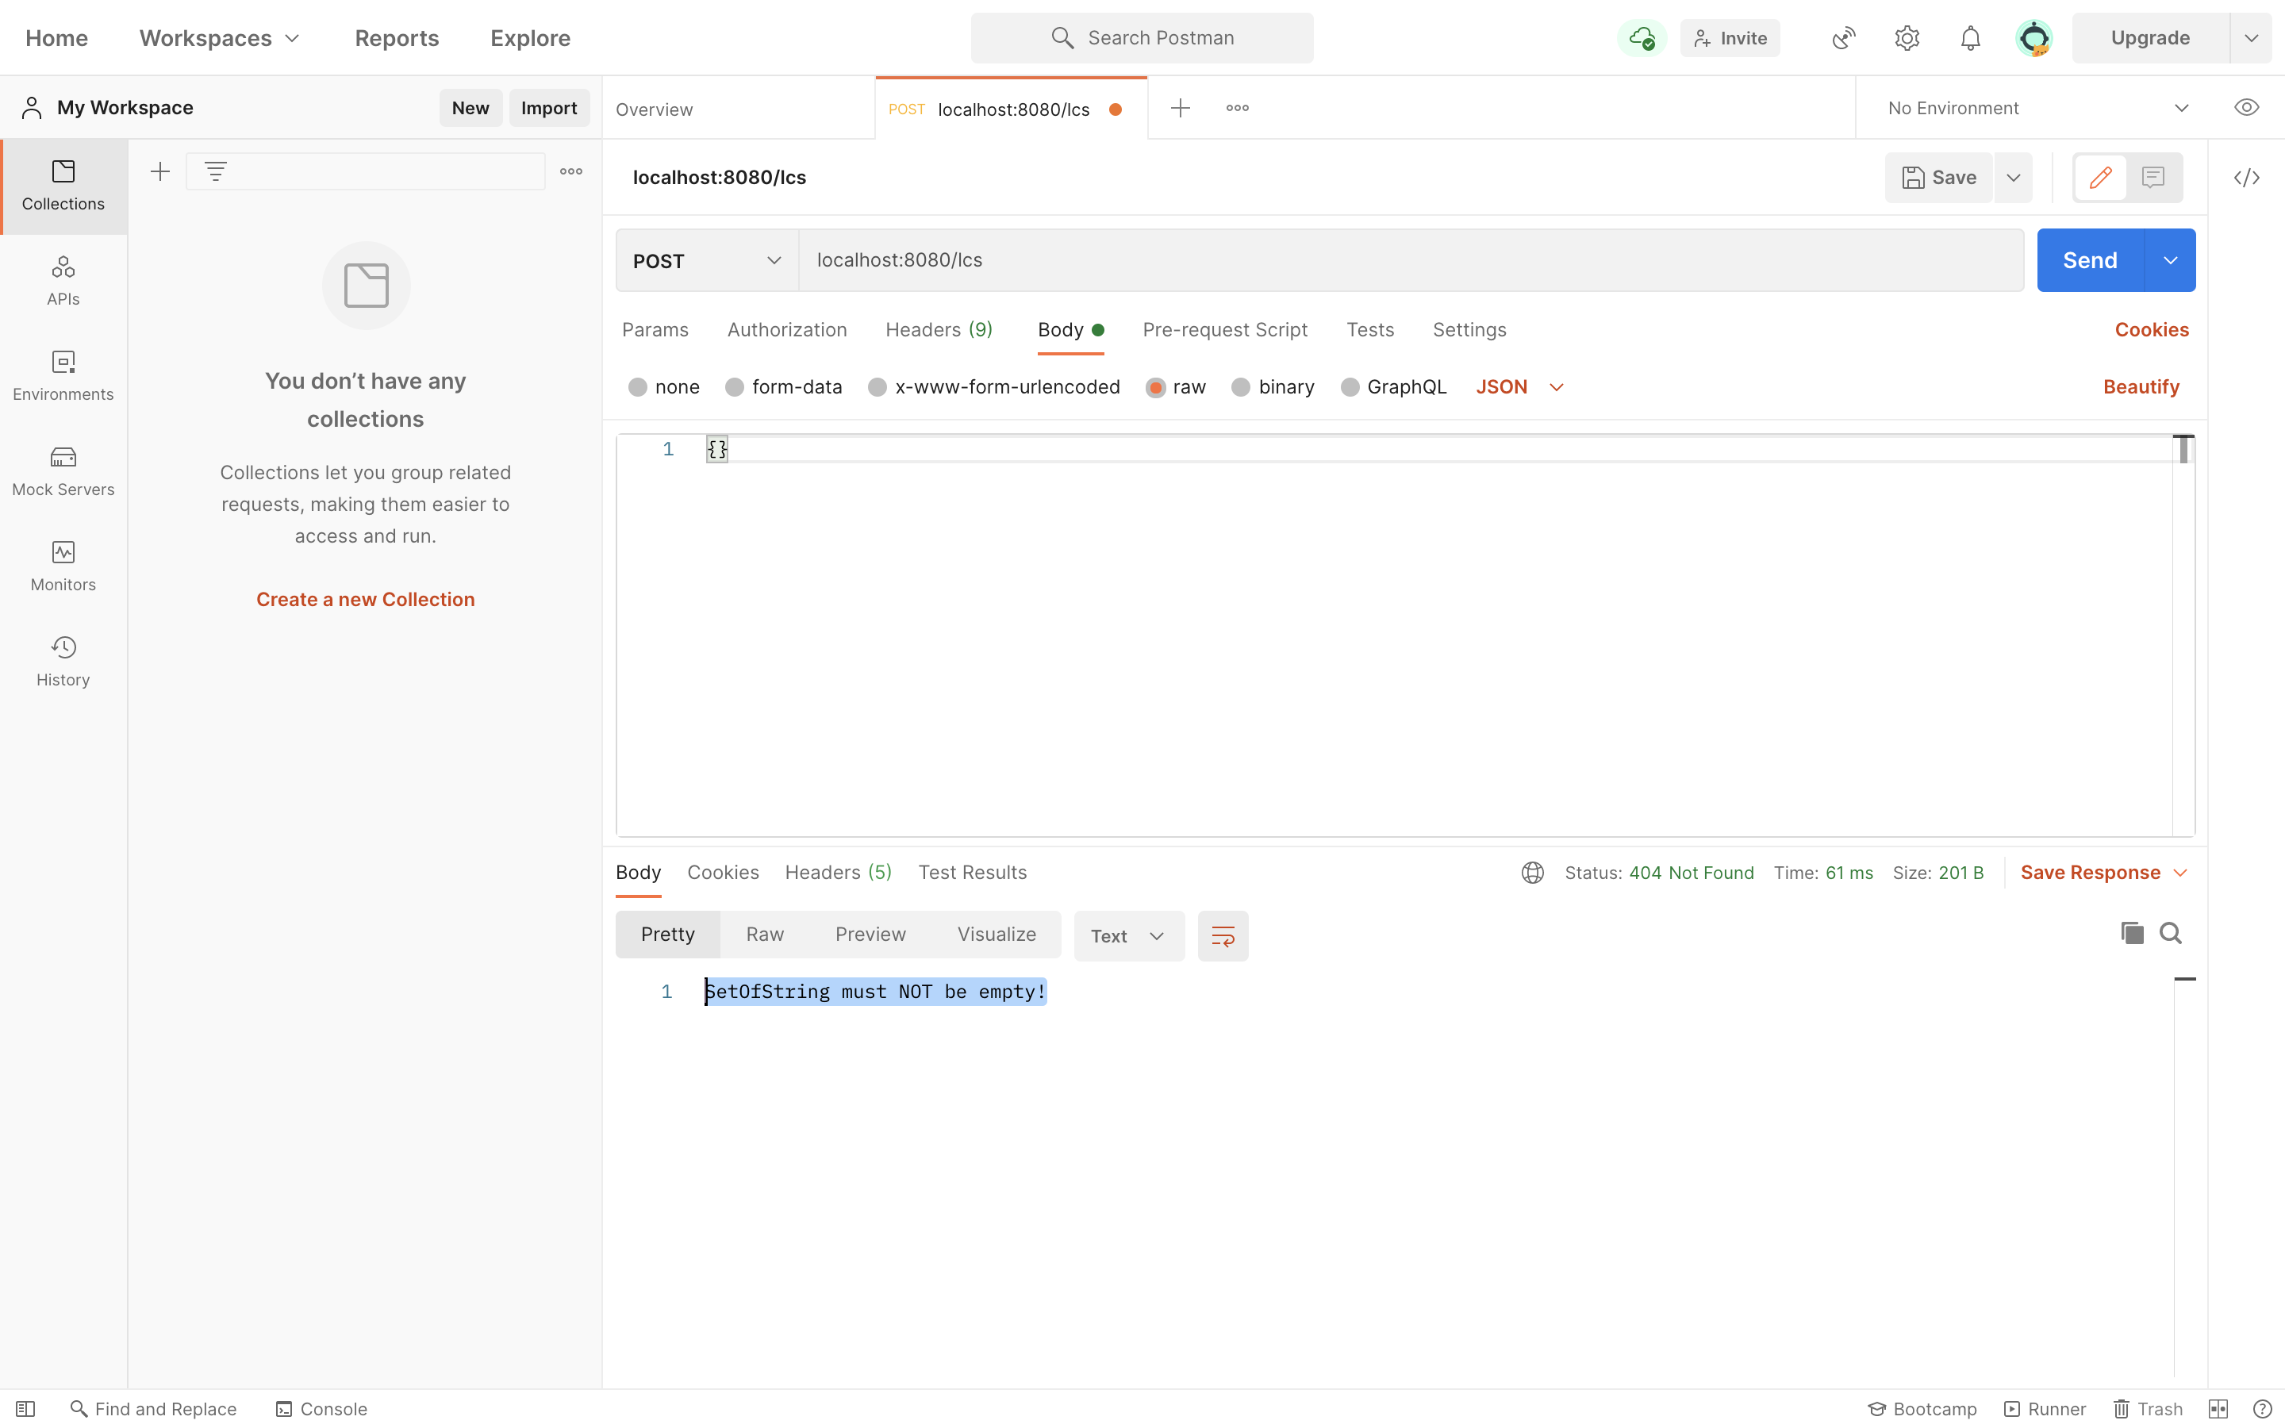

- if the setOfStrings supplied is not a set

